Lab Assignment-3.1
Prompt Engineering – Improving Prompts and Context Management

E.BALAJI
2303A51572
Batch-11

Task-1:” Zero-Shot Prompting (Palindrome Number Program)”
Prompts used for best results:
#Write a Python function `is_palindrome(n)` that returns `True` if an integer is a palindrome and `False` otherwise.
# Example usage:

Code:
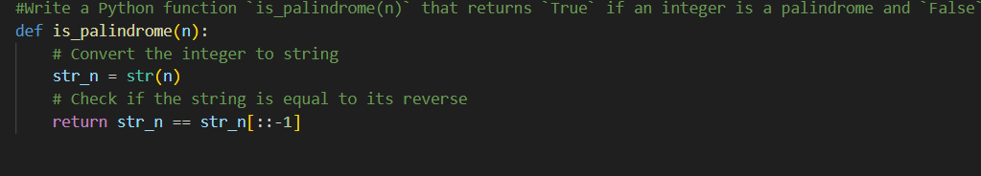
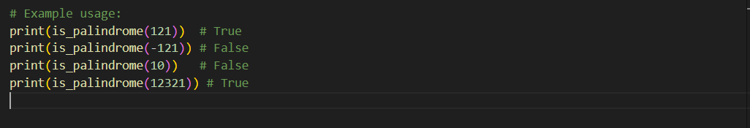

Output:
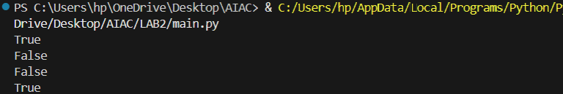
Code:
Output:

Comparision of both results: The standard is_prime function checks all numbers up to the square root of n, making it simple but less efficient for large numbers. The optimized version, is_prime_optimized, quickly eliminates even numbers and multiples of 3, then only checks numbers of the form 6k±1, reducing unnecessary checks. Both have O(√n) complexity, but the optimized version is faster for large inputs. Use is_prime for clarity and is_prime_optimized for better performance with big numbers.

Task-2: Mobile Data Usage Billing Application
Prompts used:
# Use Python programming and AI-assisted coding tools to create an application that simulates mobile data billing for a telecom service provider.
# Generate python code such that user should have Data Consumed (in GB), Plan Type (Prepaid / Postpaid),Additional Services Used (e.g., caller tune, OTT subscription, etc.)
#Implement billing logic to calculate: DC (Data Charges) – charges based on data consumption, VC (Value-added Charges) – charges for additional services, Tax – applicable tax on the total bill.
#Display an itemized bill showing: Plan Type, Data Usage and Charges, Value-added Services and Charges, Tax, Total Bill Amount
Code: 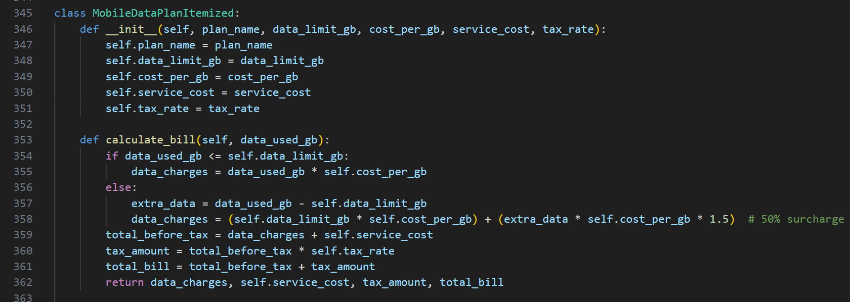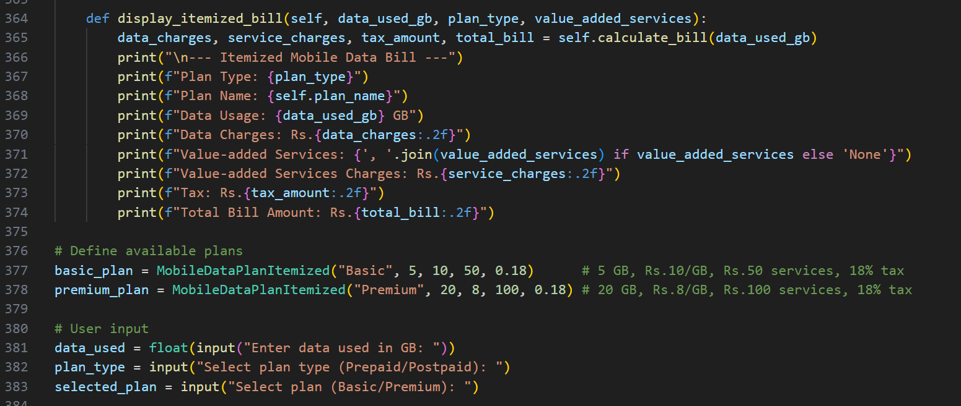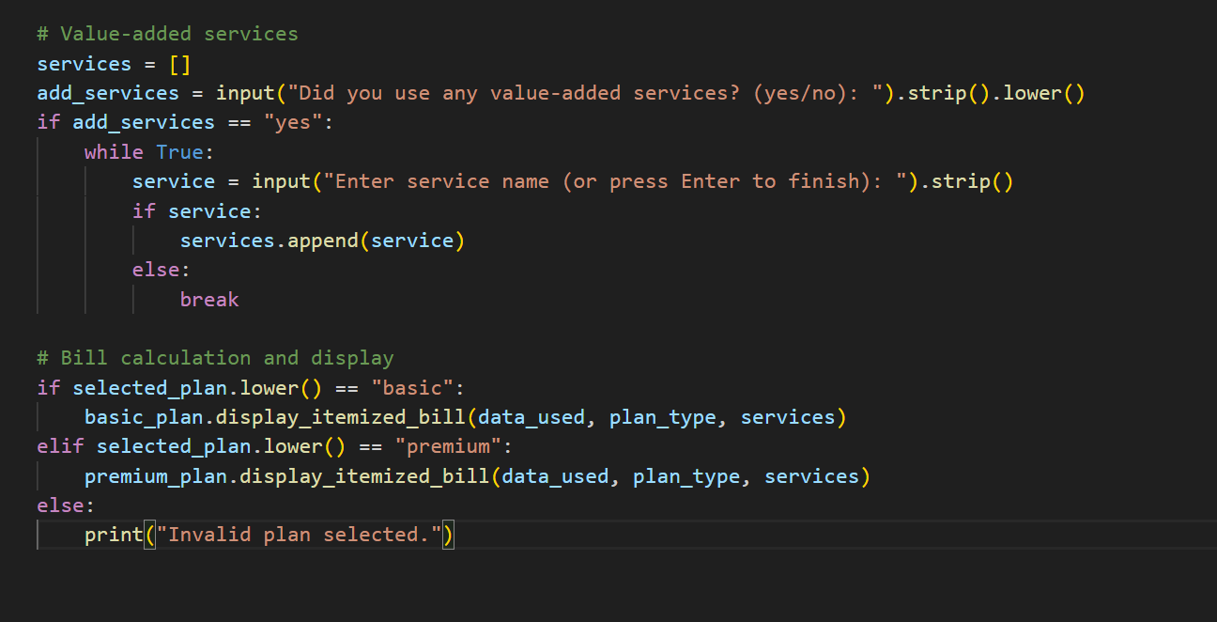

Output:
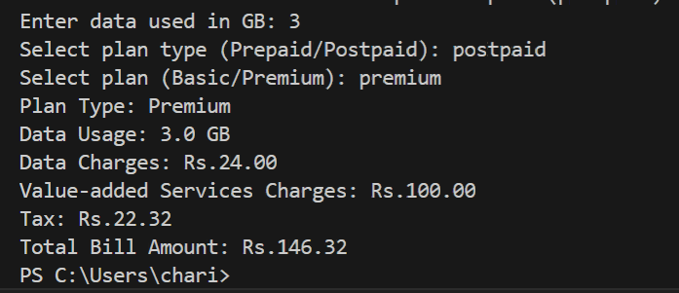
Comparision of both results:This Mobile Data Usage Billing Application helps users calculate their monthly mobile data bill in a simple and interactive way. The user selects their plan type (Prepaid or Postpaid) and chooses between a Basic or Premium plan, each with its own data limits and rates. The app asks for the amount of data used and whether any value-added services (like caller tunes or OTT subscriptions) were used. It then calculates the total bill, including extra charges for exceeding the data limit, service costs, and applicable taxes. Finally, it presents a clear, itemized bill that breaks down all charges, making it easy for users to understand exactly what they’re paying for. This makes managing and reviewing mobile expenses straightforward and transparent.

Task-3: Develop an LPG Billing System
Prompts used:
#Develop a Python application and utilize AI-assisted coding tools to build an application that calculates the LPG bill based on specified customer inputs and billing parameters.
#Generate python code such that user should have Customer Name, Customer ID, Consumption (in kg), Connection Type (Domestic / Commercial)
# Refer to the given LPG Price List to determine the price per cylinder:
# Add delivery charge input and detailed billing class with display method
# Calculate per kg price from cylinder price
Code: 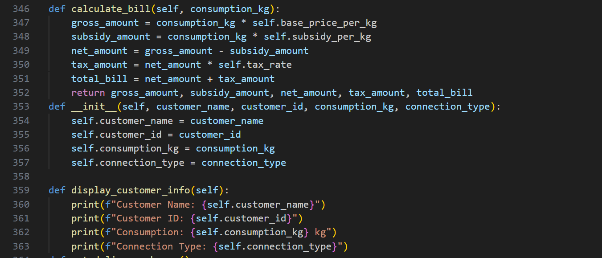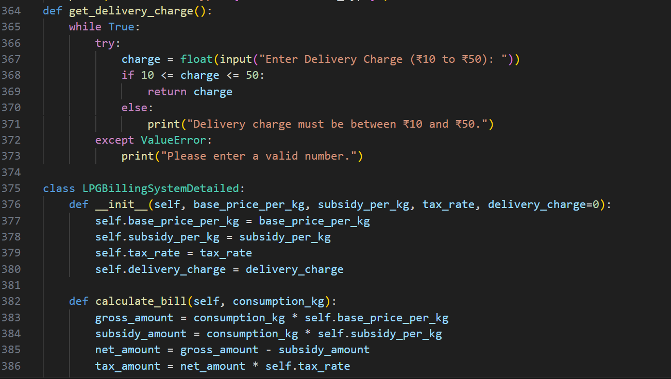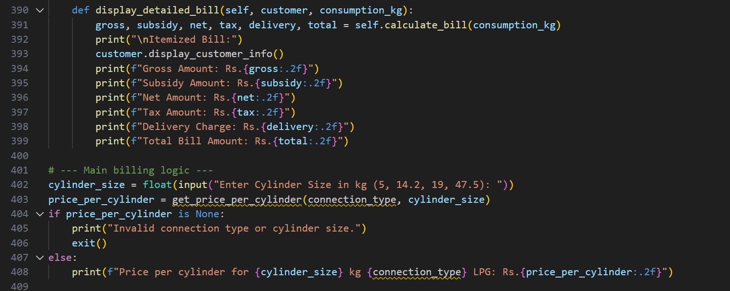 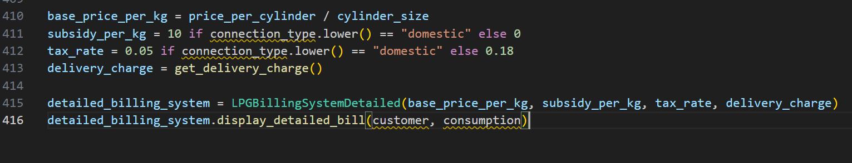

Output:
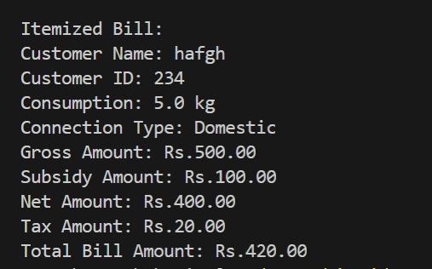

Comparision of both results:This LPG Gas Billing Application makes it easy for customers to calculate their monthly gas bill. Users enter their personal details, connection type (Domestic or Commercial), cylinder size, and the amount of gas consumed. The app automatically applies the correct price per cylinder, calculates any government subsidy, adds delivery charges, and computes the applicable tax. It then presents a clear, itemized bill showing all charges, including gross amount, subsidy, net amount, tax, and delivery fees. This helps users understand exactly what they’re paying for and ensures transparency in their LPG billing. The process is straightforward, making it simple for anyone to review and manage their household or business gas expenses.

